**Headphones Shop Website**

**Project Description:**

The "Headphones Shop Website" project is a full-stack web development project created using Django, a Python web framework, and frontend with html,css,javascript. The website serves as an online platform for users to browse and purchase headphones. It includes essential features such as user authentication, product listing, cart management, checkout process, and order tracking.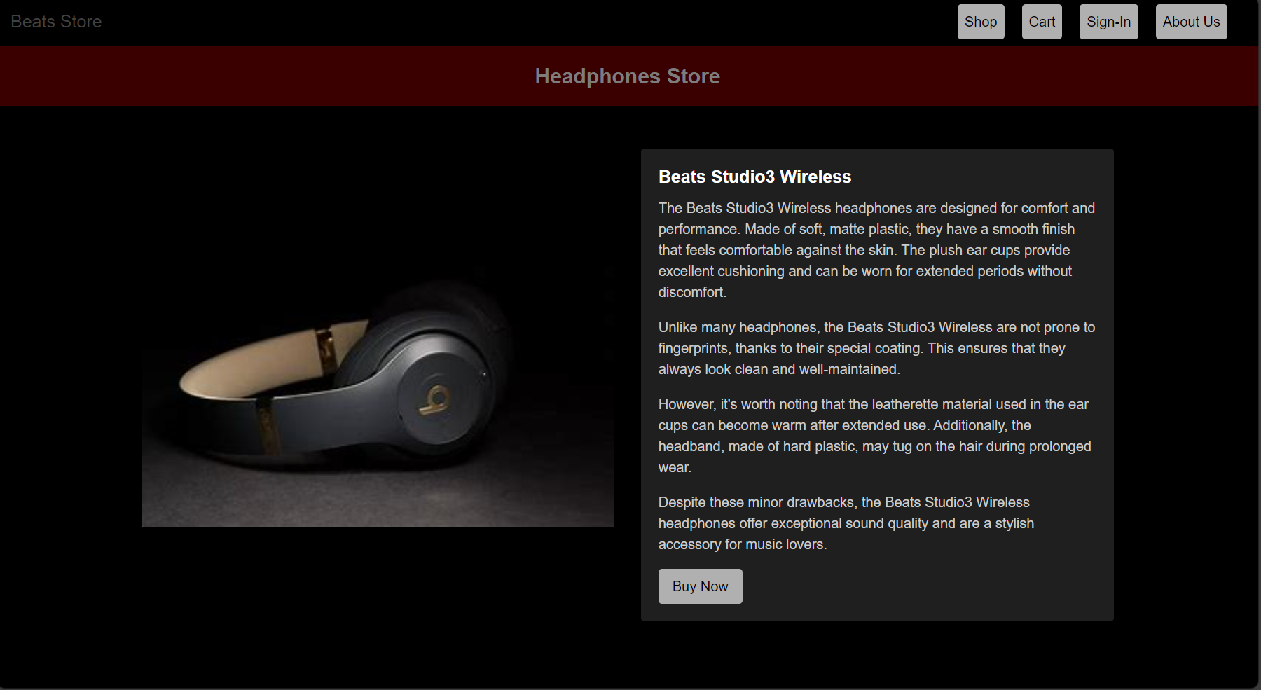

**Key Features:**

* + - User Authentication: Users can create accounts, log in, and log out to access personalized features such as viewing order history and managing profile information.
    - Product Listing: The website displays a catalog of headphones available for purchase, including details such as product name, image, description, and price.
    - Cart Management: Users can add headphones to their shopping cart, adjust quantities, and remove items as needed. The cart updates dynamically to reflect changes in the selected items.
    - Checkout Process: Once users have added items to their cart, they can proceed to checkout, where they provide shipping and payment information. The checkout process includes validation and confirmation steps.
    - Order Tracking: After completing a purchase, users can track the status of their orders, including order processing, shipment, and delivery.
    - Responsive Design: The website is designed to be responsive, ensuring optimal viewing and interaction across various devices and screen sizes, including desktops, tablets, and mobile phones.

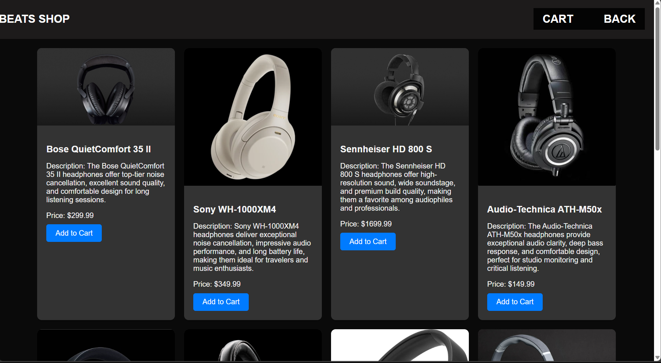

**Project Goals:**

* Develop a fully functional e-commerce website for selling headphones.
* Implement user authentication and authorization features for secure user access.
* Create a user-friendly interface for browsing products, managing cart items, and completing purchases.
* Ensure responsiveness and compatibility with different devices and screen sizes.

